**Assignment 2:**

Question 1:

AIM:

To create a program that analyses and performs functions on text file.

# Code:

"""

Assignment 2 Question 1 done by Vansh Aggarwal

Date: 21/3/24

Time of start: 13:22

"""

#Top-Level Variable Assignment

final = []

opt1 = 0

up_vowel = "AEIOU"

down_vowel = "aeiou"

#Function Creation

def create_file():

    f = open("story.txt", "w")

    f.close

    print("File Created")

def store_data(append_string):

    f = open("story.txt", "a")

    f.write(append_string + "\n")

    f.close

    print("Text Added")

def read_data():

    final = []

    f = open("story.txt", "r")

    data = f.readlines()

    f.close

    for i in data:

        final.append(i.rstrip("\n"))

    return(final)

def count_alpha():

    n = 0

    data = read_data()

    for i in data:

        for j in i:

            if j.isalpha():

                n+=1

    return(n)

def count_num():

    n = 0

    data = read_data()

    for i in data:

        for j in i:

            if j.isdigit():

                n+=1

    return (n)

def count_space():

    n = 0

    data = read_data()

    for i in data:

        for j in i:

            if j == " ":

                n+=1

    return (n)

def count_special():

    n = 0

    data = read_data()

    for i in data:

        for j in i:

            if j != " " and not(j.isalpha()) and not(j.isdigit()) :

                n+=1

    return (n)

def count_upper_vowel():

    n = 0

    data = read_data()

    for i in data:

        for j in i:

            if j in up_vowel :

                n+=1

    return (n)

def count_lower_vowel():

    n = 0

    data = read_data()

    for i in data:

        for j in i:

            if j in up_vowel :

                n+=1

    return (n)

def count_consonant():

    n = 0

    data = read_data()

    for i in data:

        for j in i:

            if j not in up_vowel and j not in down_vowel and j.isalpha():

                n+=1

    return (n)

def count_lines():

    n = len(read_data())

    return (n)

def count_words():

    n = 0

    data = read_data()

    for i in data:

        l = i.split()

        print (l)

        n +=len(l)

    return(n)

#check file

while True:

    print ("Do you want to erase the file or continue with the previous file: ")

    opt2 = int(input ("Enter 1 for yes and 2 for no: "))

    if opt2 == 1:

        create_file()

        break

    elif opt2 == 2:

        print ("File Retained.")

        break

    else:

        print ("Try again.")

#Main loop

while opt1 != 6:

    print ("""

The menu options are:-

1) Add more content to the file.

2) Display the entire file content

3) No. of different types of characters used

4) No. of uppercase, lowercase vowels and no.of consonants

5) No. of words and No. of lines

6) Exit

""")

    opt1 = int(input("Enter the option no: "))

    if opt1 == 1:

        appendage = input ("Enter the string to be added: ")

        store_data(appendage)

    elif opt1 == 2:

        for i in read_data():

            print (i)

    elif opt1 == 3:

        print ("The number of Alphabets used in the given file is: ", count_alpha())

        print ("The number of Numbers used in the given file is: ", count_num())

        print ("The number of Spaces used in the given file is : ", count_space())

        print ("The number of Special Characters used in the given file is: ", count_special())

    elif opt1 == 4:

        print("The number of Uppercase Vowels are: ", count_upper_vowel())

        print ("The number of Lowercase Vowels are: ", count_lower_vowel())

        print ("The number of consonants are: ", count_consonant())

    elif opt1 == 5:

        print ("The number of words are: ", count_words())

        print ("The number of lines are:", count_lines())

    elif opt1 == 6:

        print ("The program will Exit now.")

        break

    else:

        print("Invalid Input. Try again")

# Sample Output:

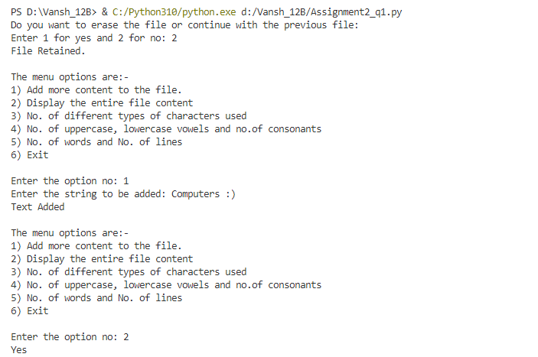

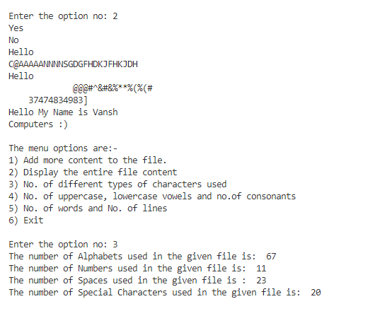

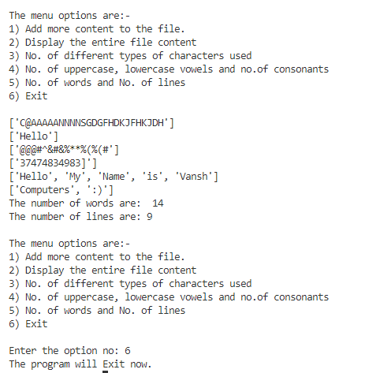

Question 2:

AIM:

Write menu driven python program to create a text file performance.txt and store information of students like (name, roll no, marks of three subjects) and perform various operations.

# Code:

"""

Assignment 2 Question 2 done by Vansh Aggarwal

Date: 22/3/24

Time of start: 12:32

"""

#Top-Level Variable Assignment

#Function Creation

def create_file():

    f = open("performance.txt", "w")

    f.close

    print("File Created")

#check file

while True:

    print ("Do you want to erase the file or continue with the previous file: ")

    opt2 = int(input ("Enter 1 for yes and 2 for no: "))

    if opt2 == 1:

        create_file()

        break

    elif opt2 == 2:

        print ("File Retained.")

        break

    else:

        print ("Try again.")

#Main Function Creation

def performance_percent(m1,m2,m3):

    percent = ((int(m1)+int(m2)+int(m3))/3)

    return (percent)

def add_info():

    name = input("Name of Student: ")

    rollno = input ("Enter Roll No: ")

    m1 = int(input("Marks in Subject 1: "))

    m2 = int(input("Marks in Subject 2: "))

    m3 = int(input("Marks in Subject 3: "))

    percentage = performance_percent(m1, m2, m3)

    f = open("performance.txt", "a")

    f.write (name +" "+ rollno +" "+ str(m1) +" "+ str(m2)  +" "+ str(m3) +" "+ str(percentage) + "\n")

    f.close

    print("Student Data Added. ")

def read_data():

    final = []

    f = open("performance.txt", "r")

    data = f.readlines()

    f.close

    for i in data:

        j = i.split()

        final.append(j)

    return(final)

def name_percent():

    raw = read_data()

    for i in raw:

        print (f'{i[0]:<10}', ":  ", f'{i[5]:<10}')

def top3():

    raw = read_data()

    for i in range (len(raw)):

        for j in range (i):

            if raw[i][5] > raw[j][5]:

                raw [i] , raw [j]  =  raw[j], raw[i]

    print (raw[0][0], raw [1][0], raw[2][0], sep = "\n")

def name_search(search_str):

    raw = read_data()

    for i in raw:

        if i [0] == search_str:

            return (i)

            break

    else:

        return(None)

while True:

    print ('''

Options:

1) Add Student Info

2) Display in tabular way all students information.

3) Display all the student name and their percentage.

4) Display the top three students as per the percentage.

5) Search for a particular student( by name)

6) Exit. ''' )

    opt1 = int(input("Enter the option selected: "))

    if opt1 == 1:

        add_info()

    elif opt1 ==2:

        raw = read_data()

        for i in raw:

            for j in i:

                print (f'{j:<20}', end = " ")

            print ()

    elif opt1==3:

        name_percent()

    elif opt1==4:

        print ("The Top 3 Students by percentage are: ")

        top3()

    elif opt1 ==5:

        s_search = input("Enter the name: ")

        val = name_search(s_search)

        if val == None:

            print ("Name not found. ")

        else:

            for i in val:

                print (f'{i:<9}' , end = " ")

    elif opt1 ==6:

        print("The Program will quit now.")

        break

    else:

        print ("Invalid Option. ")

        print ("Please Check Again. ")

# Sample Output:

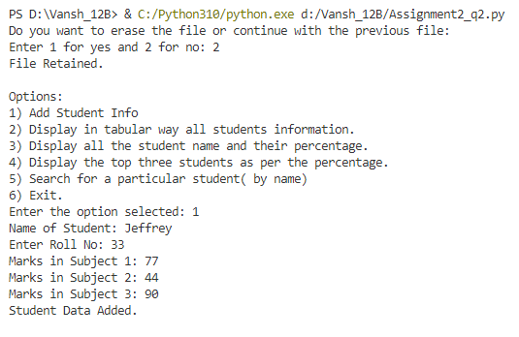

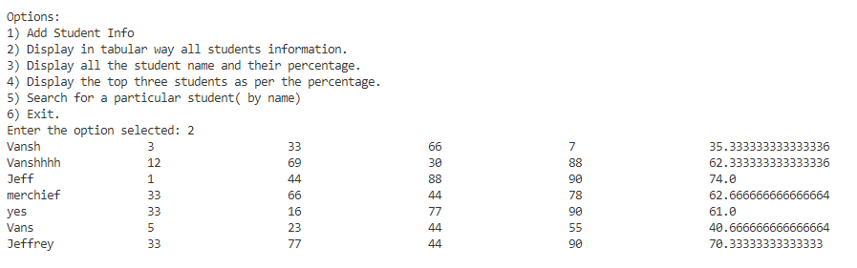

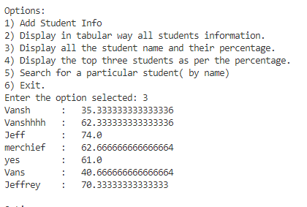

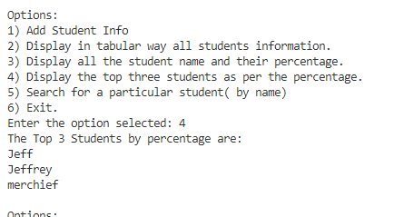

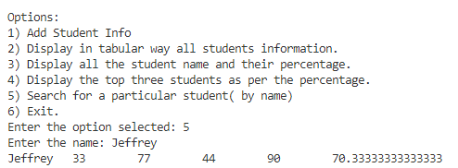

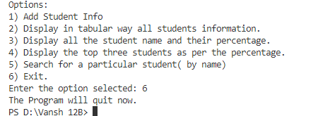

Question 3:

AIM:

Write menu driven python program to create a text file poem.txt and store information and manipulate data.

# Code:

"""

Assignment 2 Question 3 done by Vansh Aggarwal

Date: 5/4/24

Time of start: 12:44

"""

#Top-Level Variable Assignment

import os

#Function Creation

def create_file():

    f = open("poem.txt", "w")

    f.close()

    print("File Created")

#check file

while True:

    print ("Do you want to erase the file or continue with the previous file: ")

    opt2 = int(input ("Enter 1 for yes and 2 for no: "))

    if opt2 == 1:

        create_file()

        break

    elif opt2 == 2:

        print ("File Retained.")

        break

    else:

        print ("Try again.")

#Main Function Creation

def add_content(content):

    f = open("poem.txt", "a")

    f.write(content + "\n")

    f.close()

    print ("Content has been added. ")

def display_content():

    final = []

    f = open("poem.txt", "r")

    data = f.readlines()

    f.close()

    for i in data:

        final.append(i.rstrip("\n"))

    return(final)

def count_word(word):

    data = display_content()

    temp_count = 0

    for i in data:

        if word in i:

            temp_count += i.count(word)

    return (temp_count)

def remove_line(alphabet):

    data = display_content()

    fout = open("temp.txt", "w")

    fout.close()

    fout = open("temp.txt", "a")

    for i in data:

        if i != '' and i[0][0] != alphabet:

            fout.write(i + "\n")

    fout.close()

    os.remove("poem.txt")

    os.rename("temp.txt", "poem.txt")

    print("Lines Removed")

def file_size():

    data = display_content()

    count = 0

    for i in data:

        for j in i:

            count +=1

    return (count)

def used_word():

    data = display_content()

    output = ""

    for i in data:

        line = i.split()

        for j in line:

            temp = count_word(j)

            if temp > count_word(output):

                output = j

    return (output)

def remove_extra():

    fout = open("rice.txt", "w")

    fout.close()

    fout = open("rice.txt", "a")

    data = display_content()

    for i in data:

        line = i.split()

        new_line = ''

        for j in line:

            new_line = new_line + j + " "

        fout.write(new_line + "\n")

    fout.close()

    os.remove("poem.txt")

    os.rename("rice.txt", "poem.txt")

while True:

    print( """

Options:

1) Add more content to the file.

2) Display the entire file content

3) Count the number of times a particular word is present in the file.

4) Remove the lines which start with a particular alphabet.

5) Display the size of the file.

6) Display the most used word from the file.

7) Remove the extra spaces and blank lines from the file.

8) Exit

""")

    opt1 = int(input("Enter the option number: "))

    if opt1 ==1:

        append_str = input("Enter the content to be appended:  ")

        add_content(append_str)

    elif opt1==2:

        print()

        print()

        data = display_content()

        for i in data:

            print (i)

    elif opt1==3:

        wrd = input("Enter the word to be counted: ")

        word_count = count_word(wrd)

        print (word_count)

    elif opt1==4:

        al = input("Enter the alphabet: ")

        remove_line(al)

    elif opt1==5:

        cnt = file_size()

        print ("The file size is: ", cnt)

    elif opt1==6:

        most_used = used_word()

        print (most_used)

    elif opt1==7:

        remove_extra()

        print ("Extra Spaces Removed. ")

    elif opt1==8:

        print("The program will now exit.")

        break

    else:

        print("Not a valid input.")

        print("Please try again.")

# Sample Output:

